SceneTrace: Cross-Camera Person Observation and Retrieval
Hanzala Ajaz  Department of Artificial Intelligence  COMSATS University Islamabad  Wah Campus, Pakistan | Abdul Rehman  Department of Artificial Intelligence  COMSATS University Islamabad  Wah Campus, Pakistan

Abstract—SceneTrace is a locally deployed prototype that helps organize person observations across uploaded camera recordings. Users register labeled reference footage for each camera view, and later recordings are matched to these views using ORB, SIFT and geometric verification. YOLOX-S detects people, YuNet detects faces, and a motion-assisted tracker links observations within a recording. Clear faces are aligned and encoded with SFace so that an identifier can be reused across recordings, but only when face size, sharpness, landmark visibility, similarity and competing matches all support it. Unclear cases stay provisional, and clothing color is never used to fill the gap. Captures, observation intervals, camera labels, locations and correction history are kept in SQLite and local storage, and a browser interface supports search, galleries and annotated exports. Thirty-two functional tests confirm the software workflows but do not measure recognition accuracy. We describe the design, state the limits of the current evidence, and outline the evaluation still needed.
Index Terms—cross-camera retrieval, face recognition, multi-object tracking, person detection, video analytics, view registration

I. Introduction
Reviewing footage from several cameras by hand is slow. An analyst has to remember who appeared where and when, and piece movement together across views. SceneTrace is a prototype that records these observations and makes them searchable, while keeping every association tied to evidence in the recordings.
Its main rule is to be conservative. An identifier is reused automatically only when explicit quality and similarity checks pass; otherwise the observation stays provisional and no identity or location is claimed. This paper describes the design, reports what has and has not been verified, and proposes how the system should be evaluated. It reflects the prototype as of 29 October 2026.

II. Related Work
YOLOX is an anchor-free detector with a decoupled head and SimOTA label assignment [1]. Its COCO-pretrained model provides our person detections, although detector confidence says nothing about identity. YuNet is a compact face detector that also returns landmarks for alignment [2]. SFace trains face embeddings with a loss that balances identity separation against noisy training samples [3]. We use these pretrained models, and their published results do not tell us how they perform on our recordings.
For tracking, Deep SORT adds a learned appearance metric to SORT to hold identities through occlusion [4], and ByteTrack associates low-confidence detections with existing tracks to reduce fragmentation [5]. SceneTrace implements neither. It uses a simpler motion-assisted overlap tracker, and these methods mark the next step.
SIFT provides local features that survive changes in scale and orientation [6], and ORB is an efficient alternative [7]. Such features can match a registered view, but they cannot recognize an unseen room from an arbitrary angle. Our contribution is the integration of these parts with persistent records, quality checks and correction history. It should be judged by measured false associations, missed observations, identity switches and viewpoint rejection, not by functional tests alone.

III. System Design

A. Overview
A recording is matched to a registered camera view, people and faces are detected, observations are tracked within the recording, and face evidence decides whether an identifier is reused, created or left provisional (Fig. 1).

B. View Registration and Detection
ORB and SIFT features from each labeled reference video are stored. A new recording is assigned to a view only if geometric verification confirms that the matched keypoints agree on a single transformation. Otherwise its location stays unresolved, and a background worker rechecks it when new views are registered. YOLOX-S finds people and YuNet finds faces independently, so a face can still be used when the body is not fully visible.

C. Tracking and Identifier Association
A motion-assisted tracker links detections across frames and produces an observation interval for each person. It has no appearance model, so identity switches are possible when people cross or are occluded. For that reason, identity across recordings comes from faces rather than from the tracker.
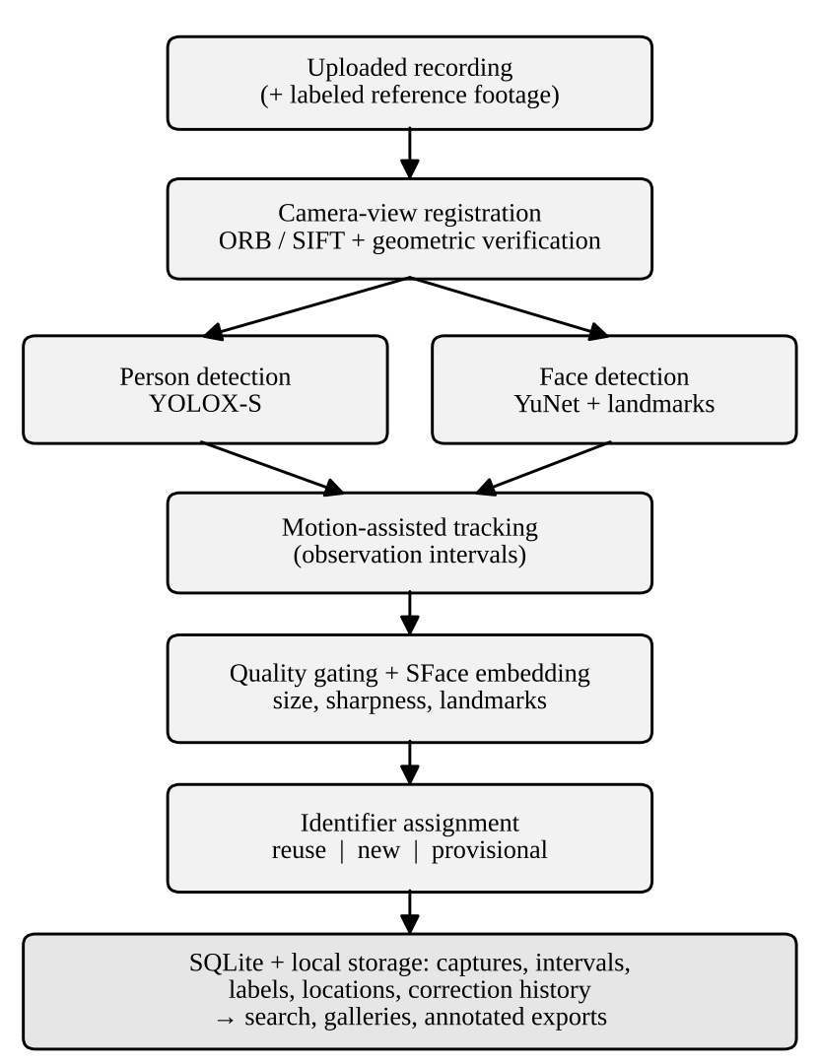
Fig. 1. SceneTrace processing pipeline.
A face is used only if it is large enough, sharp enough and has visible landmarks. Qualifying faces are aligned and encoded with SFace, then compared with the stored representation of each known identifier. Using cosine similarity, the usual choice for hypersphere embeddings,
s(e, c_{k}) = e · c_{k} / (||e|| ||c_{k}||) (1)
where e is the observed face embedding and c the stored representation of identifier k. An identifier is reused only if the best score reaches a threshold τ and exceeds the runner-up by a margin δ. Otherwise the observation stays provisional. This notation is ours, for exposition, and the values of τ and δ must be calibrated on representative data (Section V). A background worker also refreshes the quality assessment of stored evidence.

D. Storage and Interface
Original-resolution captures, intervals, camera labels, locations and correction history are stored in SQLite and local files. Corrections are added to a history instead of overwriting earlier records. Through the browser, users analyze videos, search by photograph or identifier, browse galleries and export annotated tracking videos. Background workers handle processing, quality refresh, location rechecks and limited recovery of interrupted jobs.

IV. Implementation and Verification
SceneTrace runs locally, and recordings, captures and the database stay in local storage. Table I lists the components.
Table I
SceneTrace Components
Stage | Method | Role
View registration | ORB, SIFT, geometric verification | Match recordings to registered views
Person detection | YOLOX-S (COCO-pretrained) | Localize people
Face detection | YuNet | Localize faces and landmarks
Tracking | Motion-assisted overlap tracker | Link observations within a recording
Face representation | Aligned SFace embeddings | Reuse identifiers across recordings
Storage | SQLite, local files | Captures, intervals, corrections
Interface | Browser application | Analysis, search, galleries, export

Thirty-two functional tests cover identifier persistence, view registration, source deletion and playable annotated exports. They show that the application works as designed, not how often recognition is correct. We therefore make no claim of recognition accuracy, superiority to published trackers, or production readiness.

V. Proposed Evaluation
We plan to annotate multi-camera recordings and measure four things: false associations (an identifier reused for a different person), missed observations, identity switches (reported with IDF1), and viewpoint rejection (unregistered views correctly left unassigned). The recordings should vary lighting, resolution, camera angle and face visibility. Sweeping τ and δ gives operating curves, and ablating the quality checks and the margin rule shows what each contributes. The tracker should also be compared with Deep SORT and ByteTrack. Results need confidence intervals and a breakdown across subject groups, since pretrained face models may not perform evenly.

VI. Limitations
Identity across recordings depends on faces, so a person whose face is never clear gets no reusable identifier. The tracker may switch identities under occlusion, locations are limited to registered views, and the pretrained models have not been validated on our recordings. Because face-based retrieval is privacy-sensitive, any real deployment needs human review of matches, lawful handling of recordings and biometric data, and stronger operational controls.

VII. Conclusion
SceneTrace combines registered-view location, person and face detection, motion-assisted tracking and quality-gated face association with auditable local records. Its functional tests show that the workflows run, but recognition performance remains unmeasured. Next steps are the evaluation above, stronger tracking, body-based re-identification for cases without usable faces, and broader operational controls.

References
[1] Z. Ge, S. Liu, F. Wang, Z. Li, and J. Sun, “YOLOX: Exceeding YOLO series in 2021,” arXiv preprint arXiv:2107.08430, 2021.
[2] W. Wu, H. Peng, and S. Yu, “YuNet: A tiny millisecond-level face detector,” Mach. Intell. Res., 2023, doi: 10.1007/s11633-023-1423-y.
[3] Y. Zhong, W. Deng, J. Hu, D. Zhao, X. Li, and D. Wen, “SFace: Sigmoid-constrained hypersphere loss for robust face recognition,” IEEE Trans. Image Process., 2021, doi: 10.1109/TIP.2020.3048632.
[4] N. Wojke, A. Bewley, and D. Paulus, “Simple online and realtime tracking with a deep association metric,” arXiv preprint arXiv:1703.07402, 2017.
[5] Y. Zhang et al., “ByteTrack: Multi-object tracking by associating every detection box,” arXiv preprint arXiv:2110.06864, 2022.
[6] D. G. Lowe, “Distinctive image features from scale-invariant keypoints,” Int. J. Comput. Vis., vol. 60, no. 2, pp. 91–110, 2004, doi: 10.1023/B:VISI.0000029664.99615.94.
[7] E. Rublee, V. Rabaud, K. Konolige, and G. Bradski, “ORB: An efficient alternative to SIFT or SURF,” in Proc. IEEE Int. Conf. Comput. Vis. (ICCV), 2011, pp. 2564–2571.

